Exercise 2: Writing Basic JUnit Tests:

Caluclator class:

**public** **class** Caluclator {

**public** **int** add(**int** a,**int** b)

{

**return** a+b;

}

}

Test Class:

import static org.junit.jupiter.api.Assertions.*;

import org.junit.jupiter.api.Test;

class TestCalc {

@Test

void test() {

Caluclator c=new Caluclator();

assertEquals(0,c.add(9,1));

}

}

Output:

1.

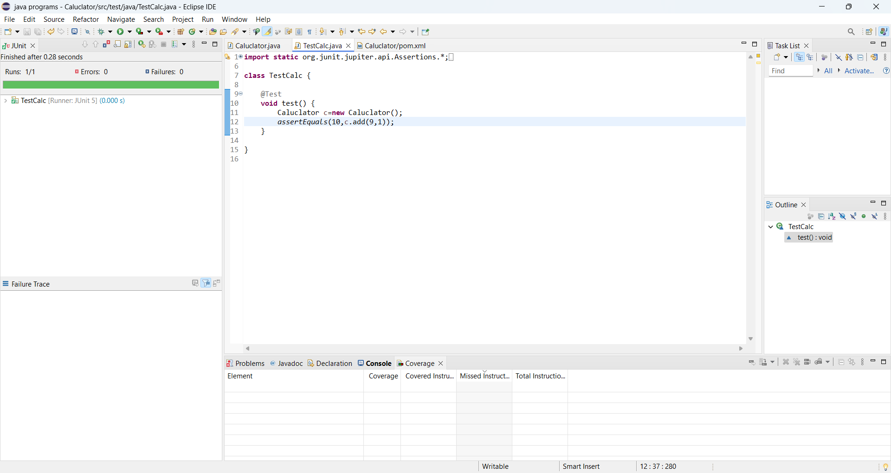

2.

